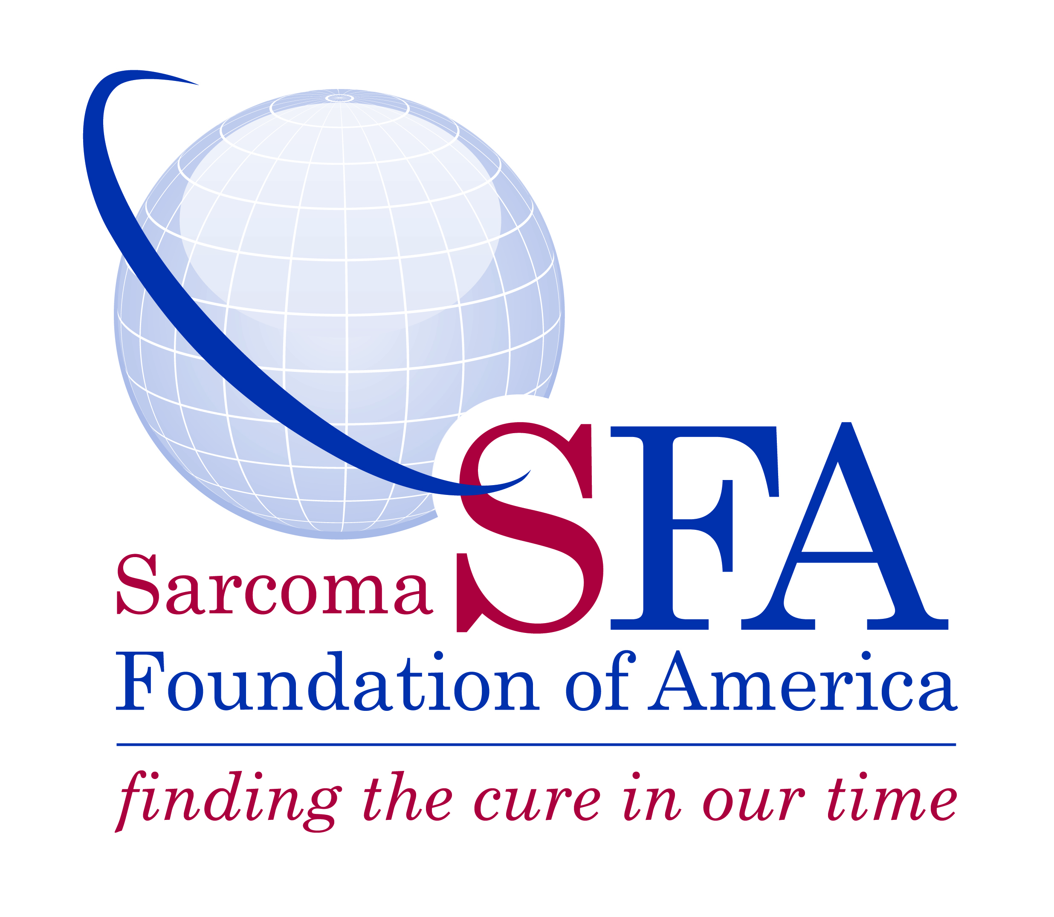
SARCOMA FOUNDATION OF AMERICA
www.curesarcoma.org

Contact: Elinore Tibbetts
301-253-8687, ext. 111
etibbetts@curesarcoma.org

Sarcoma Foundation of America’s 2nd Annual Last Mile Research Grant Opportunity Now Accepting Applications
DAMASCUS, Md. – January 19, 2023 – The Sarcoma Foundation of America (SFA) announced today it has begun accepting proposals for its Last Mile Research Grant. In its second year, the research funding opportunity provides one-year grants of $150,000, to support translational science research on the etiology, molecular biology, pathogenesis, diagnosis, and treatment of human sarcomas. Completed applications must be submitted by April 3, 2023, at 5:00 pm EDT.

This grant mechanism is available for sarcoma researchers to provide funding to strengthen the resubmission of a National Cancer Institute (NCI) NCI R01 proposal where the member is the project director and principal investigator on the application. The R01 must have scored in the 50th percentile or better, but outside the current NCI pay line.
Considerations in a funding decision will include the following: the innovation and impact of the research proposed, the financial circumstances and needs of the investigator, and the likelihood of a success in moving the proposal's score within the funding range following resubmission. The application for this grant should be within nine months from the initial R01 notification. If funded by SFA, the expectation is that funded applicants would be successfully resubmitted to the National Institutes of Health.
In support of our overall mission to fund research and increase awareness and advocacy for sarcoma patients and their families, the goal of the SFA grant program is to encourage research that results in improved therapeutic options for sarcoma patients.
Questions about SFA research grants can be sent to sfagrants@curesarcoma.org. Please refer to the SFA Last Mile Grant FAQ for additional information. SFA follows the practices outlined in the “U.S. Department of the Treasury Anti-Terrorist Financing Guidelines: Voluntary Best Practices for U.S. Based Charities.”

# # #

About the Sarcoma Foundation of America
The Sarcoma Foundation of America (SFA), a 501(c)(3) nonprofit charitable organization, is an advocate for increased research to find new and better therapies with which to treat patients with sarcoma. The organization raises money to privately fund grants for sarcoma researchers and conducts education and advocacy efforts on behalf of sarcoma patients. For more information, please visit www.curesarcoma.org.

About Sarcoma
Sarcoma is a rare cancer in adults (1 percent of all adult cancers) but rather prevalent in children (about 15% of all childhood cancers). At any one time, 50,000 patients and their families are struggling with sarcoma. Every year, nearly 16,000 new cases are diagnosed and more than 6,000 people die from the disease.

